

|  |  |
| --- | --- |
| 2e3670b57ae91437f46f849eb3e9a2ff | |
| 5e8bc56ec61ccd795e9bcf0365202198 | |



|  |
| --- |
| 1f1f38de2066662a2c29b2120275ca18 |

|  |  |  |
| --- | --- | --- |
| b424336e56b08fa8b5ef930e3b69b9bc | | |
| 92ad882b1120293fb1d9d52a77672d1c |
| cbedc2cc405faf4b79dcb1aaaa126758 | | | |
| e3d9ef904498da7ca7fb45d49d816b81 | | | |
| 48591d418d3b8fa57a9dd9d8317b4e62 | | | |
| 2101c36228938ca316b8a5f73cdfe541 | | | |
| 6660f555afe477e2f85a6ee5c4e56ecf | | |

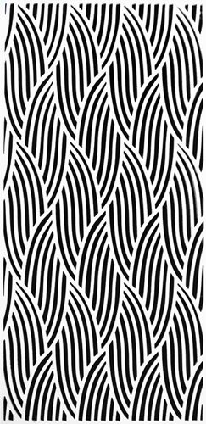

|  |
| --- |
| aaab6cdf4e44fed4963f362c4e2a91f3 |

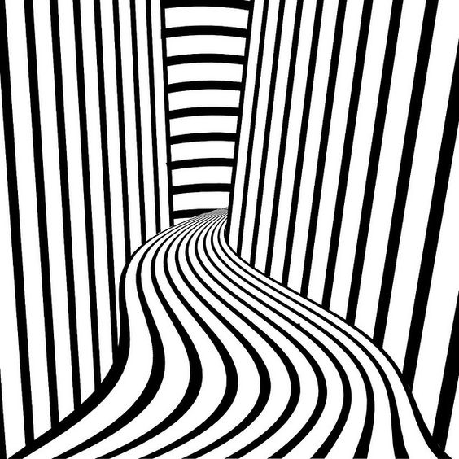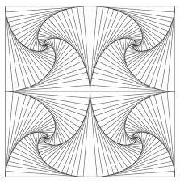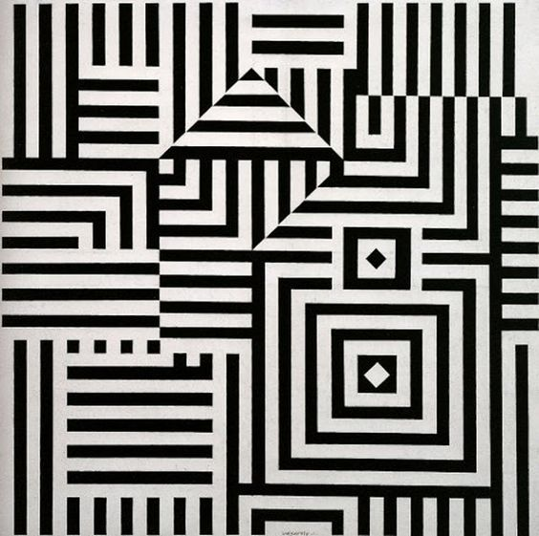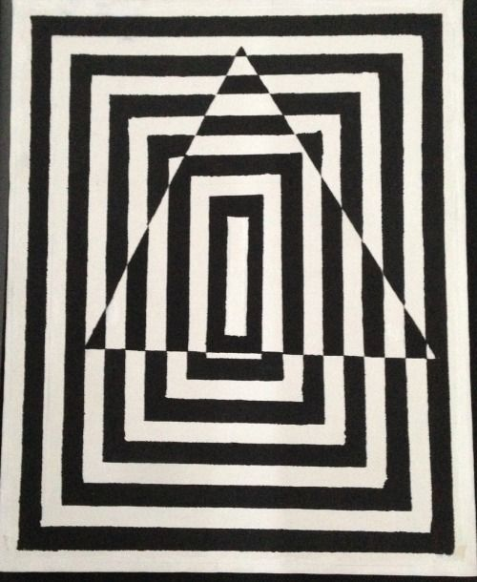

|  |  |
| --- | --- |
| 375b09b214d09ea207640f80b14aa3d8 | |
| 3cb3ca5033e20a8d706921f7f3b52fd5 | |
| 1ec0b86e57e1bf1f426e3a15fae5e6a0 | |

